The Z Community Foundation &
Zeta Phi Beta Sorority, Inc.
Zeta Zeta Zeta Chapter
P. O. Box 200184
Denver, Colorado 80220-0184

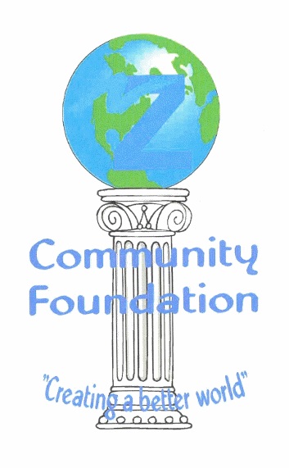

2017 SCHOLARSHIP APPLICATION FORM

INSTRUCTIONS:

Please carefully read the requirements of this application. Applicants must be a female graduating senior from a Denver Metro high school. The completed typed application and all of the supporting documents must be postmarked by April 14, 2017. Zeta Phi Beta Sorority, Inc. nor the Z Community Foundation will be responsible for applications or supporting documents that are sent through 3rd parties and do not have a postmark on or before April 14, 2017. Please use the list below to check off that all required documentation is included.

This application is also available in MS Word on our website www.zphibzzz.org and can be filled out electronically. Please be sure to check spelling and grammar as these mistakes will be counted against you. Applications postmarked after April 14, 2017 will not be considered. All handwritten applications and applications that do not fulfill the checklist requirements will be disqualified.

Required Scholarship Application Requirements Checklist:

Completed and Typed Scholarship Application within the space provided (no more than 1 page).
Official Transcript from a Denver Metro high schoo1 showing a minimum 3.0 GPA
300-500 word double spaced typed Essay
Two Letters of Recommendation (Academic, Community or Church related)

Scholarship packages should be mailed to:

Zeta Phi Beta Sorority, Inc.
ATTN: Scholarship Committee
PO Box 200184
Denver, CO 80220

Name:

Address:
City, State, and Zip: | TELEPHONE:

High School:

Email address:

will YOU be available for an in-person Interview on Saturday, April 15, 2017 between 2:00 and 5:00 p.m.? Yes NO

If Selected as a Recepient, would you be available for a recognition event on Saturday DATE TBD May 2017? YES NO

- List 3 activities you have been involved in the 11th and 12th grade that benefited the community. Please describe your role in each activity and which communities were impacted (ex. the elderly, the homeless, youth...)

- LIST 2 EXTRA-CURRICULULAR ACTIVITIES AND/OR WORK EXPERIENCE DURING HIGH SCHOOL. WHAT WAS YOUR ROLE IN EACH ACTIVITY OR JOB. PLEASE LIST NUMBER OF YEARS OF YOUR PARTICIPATION OR EMPLOYMENT FOR EACH ACTIVITY:

- ZETA PHI BETA SORORITY, INC. IS FOUNDED ON 4 PRINCIPLES. PLEASE LIST THEM. PLEASE CHOOSE ONE THAT YOU IDENTIFY WITH AND DESCRIBE HOW YOU EXHIBIT THIS PRINCIPLE:

- BRIEFLY DESCRIBE WHY YOU BELIEVE YOU SHOULD RECEIVE THIS SCHOLARSHIP:
On a separate sheet of 8 1/2 “ x 11” paper, type a 300-500 word double-spaced essay:

PROmpt: in your opinion how has social media impacted the world today? (please include details on impact to self esteem, community, and social issues)

