

**Zeta Phi Beta Sorority, Inc.**   
 Zeta Zeta Zeta Chapter

P.O. Box 200184

Margaret Neal  
*Committee Chair*

Anitra Matthews

*Chapter President*

BD21328_ Denver, CO 80220   
 zphibzzz.org

To Whom it May Concern,

It is with great honor and pleasure that we, the Zeta Zeta Zeta chapter of Zeta Phi Beta Sorority, Incorporated, request your presence and support of our bi-annual Finer Womanhood Scholarship Gospel Brunch.

As we move toward our illustrious sorority's Centennial Celebration in June of 2020 in Washington, D.C., Zeta Zeta Zeta chapter will be celebrating our 60th year of service to the Denver community. Our principles of Scholarship, Service, Sisterhood, and Finer Womanhood have led us to take-action within our community. We participate in programs such as March for Babies and Prematurity Awareness with the March of Dimes, Wreaths Across America and Women Veterans Rock in support of our military, breast cancer awareness and the feeding of the less fortunate to name a few. However, we value most the commitment we have toward scholarship. Zeta Zeta Zeta chapter has given over $20,000 in scholarships to graduating high school seniors over the last 10 years.

The Finer Womanhood Scholarship Gospel Brunch will help us in reaching our goal in providing future scholarships. We know we cannot do it without your help. We cordially invite you to be a sponsor, purchase advertisement in our program journal or purchase tickets to attend our event (tickets are $65 per person). The gospel brunch will feature some of Denver's finest gospel artists, community service awards and the presentation of the 2019 Journey to Centennial scholarship recipients.

This event will be held at the Radisson Hotel Denver Southeast 3185 South Vaughn Way Aurora, Colorado 80014, April 13, 2019 from noon till three p.m. For further information please contact Willene Collins at 720-364-6709 or Valerie Love at 303-587-6760.

Thank you in advance for your support. Please find sponsorship levels, souvenir journal, and ticket information attached.

Sincerely,

**Willene Collins & Valerie Love**

Willene Collins & Valerie Love

Chairpersons

Anitra Matthews

President - Zeta Zeta Zeta Chapter



**Zeta Phi Beta Sorority, Inc.**   
 Zeta Zeta Zeta Chapter

P.O. Box 200184

Margaret Neal

Committee Chair

Anitra Matthews

Chapter President

BD21328_ Denver, CO 80220   
 zphibzzz.org

**Event Information and Deadlines**

Zeta Zeta Zeta Chapter anticipates an audience of approximately 100 to 150 people. Please provide PDF or photo ready images. All advertisements and information must be submitted by ***April 1, 2019***.

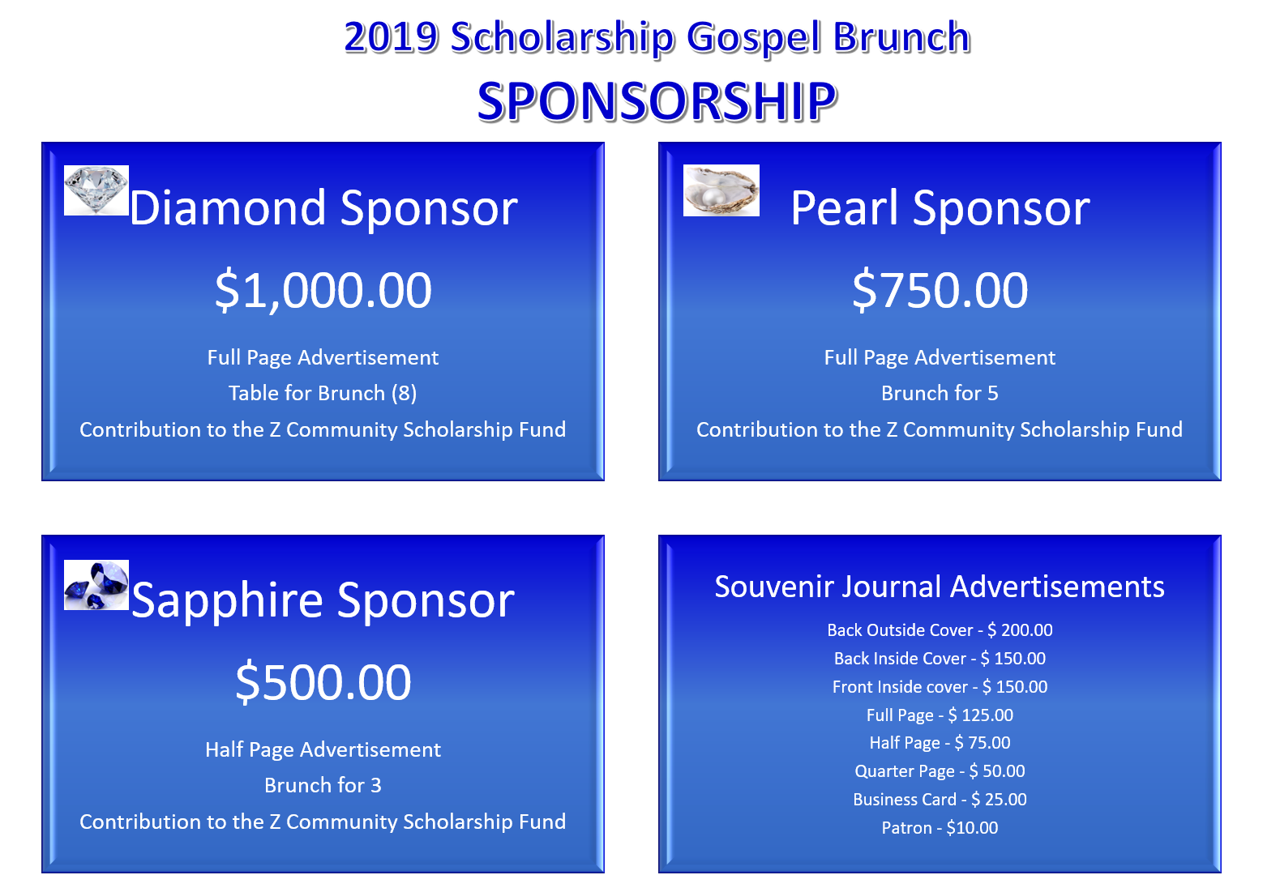

Please submit the soft copy of your advertisement or greeting to Willene Collins at [angel4u35@hotmail.com](mailto:angel4u35@hotmail.com) or Valerie Love via email at [lovev2318@gmail.com](mailto:lovev2318@gmail.com). Sponsors should make their check payable to Z Community Foundation and mail to: P.O. Box 200184, Denver, CO 80220 or can send payment via PayPal to Zcommunity@zphibzzz.org.

Purpose: Z- Community Foundation.

Thank you for your Support!!